PORR S.A. and TGE Gas Engineering will extend the LNG Terminal in Świnoujście

Warsaw, 24.02.2020 – Polskie LNG S.A., which belongs to the Group GAZ-SYSTEM, signed a consortium agreement with PORR S.A. and TGE Gas Engineering for extending the liquified natural gas regasification system (LNG) with additional SCV regasification units. The investment project will increase the current regasification capacity of the President Lech Kaczyński LNG Terminal in Świnoujście by 50%. Works will be completed by the end of 2021.
Under the consortium agreement PORR S.A. and TGE Gas Engineering will design the system and install LNG regasification units and cryopumps. The agreement covers the installation of i.a. two additional SCV units (Submerged Combustion Vaporisers), which allow to achieve a regasification capacity of 7.5 bn m3 of natural gas per year. The terminal’s current handling capacity is 5 bn m3 of natural gas per year.
Extending the LNG Terminal in Świnoujście is part of Poland’s strategy to gain energy independence. Increasing regasification capacity is the first step of this two-step investment project. In the second step, it is assumed to build a second wharf, a third LNG tank and a railway sidetrack for tank cars and ISO containers.
„For us the contract for extending the gas terminal in Świnoujście is another major project in power engineering. Together with TGE Gas Engineering we will proceed with its execution being fully aware of its importance for Poland’s energy safety and engaging our consortium’s full potential of resources and experience”, said Piotr Kledzik, President of the Board of PORR S.A.

Facts and figures in a nutshell
Type of project: | Extension of the liquified natural gas regasification system at the LNG terminal in Świnoujście
Scope of works: | Design & Build
Client: | Polskie LNG (GAZ-SYSTEM Group)
Contractor: | PORR S.A., TGE Gas Engineering
Start of works: | First half of 2020
Completion date: | December 2021

Photo
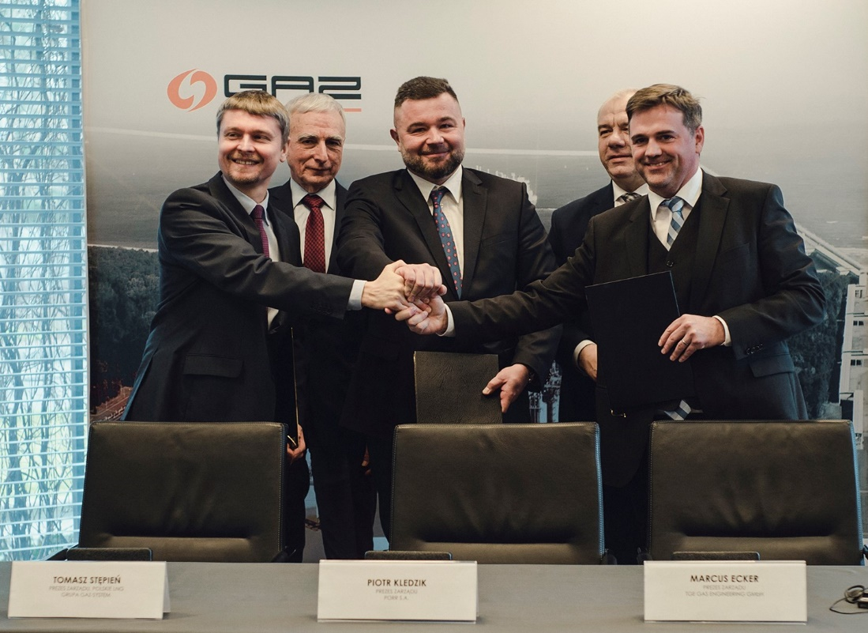
Caption: Signing the agreement with Polskie LNG (GAZ-SYSTEM Group)
From left to right: Tomasz Stępień (President of the Board of Polskie LNG), Piotr Naimski (Secretary of State in the Chancellery of the Prime Minister of Poland, Government Plenipotentiary for Strategic Energy Infrastructure), Piotr Kledzik (President of the Board of PORR S.A.), Jacek Sasin (Minister of State Assets), Marcus Ecker (President of the Board of TGE Gas Engineering) ©GAZ-SYSTEM
In case of questions, please contact:
Cornelia Harlacher
Head of Media Relations & Digital Communications
PORR AG
M +43 664 626 5698
comms@porr-group.com
Dominik Heiden
Media Relations Specialist
PORR AG
M +43 664 626 5867
comms@porr-group.com

