PORR S.A. will modernise a section of the strategic LK E59 railway line

Warsaw, 27.01.2020 – PKP Polskie Linie Kolejowe and PORR S.A. have signed an agreement for modernising railway line E59 running from Poznań to Szczecin, in the section from Krzyż to Dobiegniew. The task will be implemented under the project „Works on railway line E59 in the section Wronki – Słonice”. The contract’s net value is more than PLN 374m (ca. EUR 88m), and the date of completing the investment has been set for the fourth quarter of 2022.
Within 34 months, PORR S.A. will modernise track systems together with the related infrastructure of railway line E59 in the section Krzyż – Dobiegniew (from km 81 to km 105). The task includes the following range of works: reconstruction of about 47 km of tracks on railway line no. 351, construction of 12 switches, reconstruction or construction of engineering structures (15 culverts, 9 bridges, 9 viaducts), modernisation of 6 railway crossings. The contract also provides for the reconstruction of an overhead line along the whole section of works, as well as the construction of 6 platforms which will be fully adapted for people with disabilities.
“We are very pleased to be a contractor of such an important investment project, both for the Polish and the international passenger and freight transportation. The contract for the modernisation of the E59 railway line is also essential to us – we perceive it as proof of the strong position held by PORR S.A.’s railway department”, said Piotr Kledzik, PORR S.A. CEO.
The contract signed by PKP PLK and PORR S.A. is one out of four agreements concluded for finalising modernisation works on the strategic E59 railway line connecting Poznań and Szczecin. This investment project, worth in total PLN 1.4 bn, will allow passenger trains in 2022 to travel on the E59 railway line at a speed of up to 160 km per hour, and freight trains at a speed of up to 120 km per hour. As a result, this will shorten the travel time of a journey from the capital of Greater Poland to West Pomerania by 50 minutes, besides improving the freight carriage conditions by increasing access to ports in West Pomerania.

Facts and figures at a glance
Project name: | Modernisation of track systems and the related infrastructure on railway line E59 in the section Krzyż – Dobiegniew, from km 81.877 to km 105.820 under the project: Works on railway line E59 in the section Wronki – Słonice
Scope of services: | Build
Client: | PKP Polskie Linie Kolejowe
Contractor:  Contract value: | PORR S.A.  EUR 88m (PLN 374m)
Beginning of works: | 2020
Planned completion: | November 2022

Photo
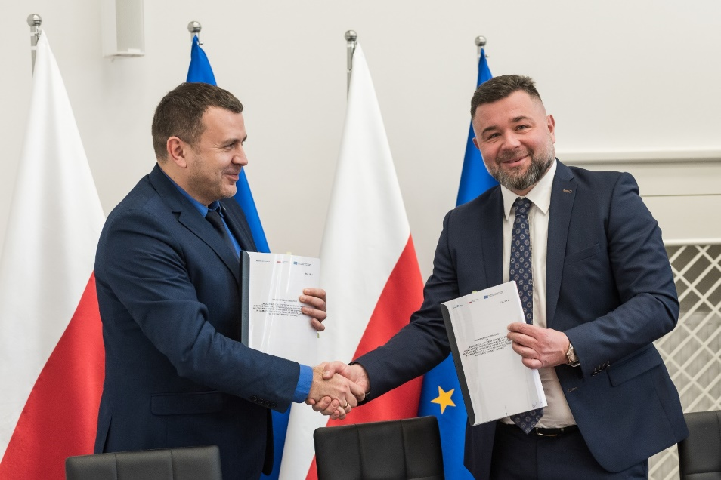
Caption: The signing ceremony for modernization of E59 railway line
from left to right: Ryszard Magdziak (PKP PLK S.A., Vice-Director of the Investment Implementation Centre), Piotr Kledzik (PORR S.A., CEO). ©PORR

For enquiries, please contact:
Cornelia Harlacher
Head of Media Relations & Digital Communications
PORR AG
M +43 664 626 5698
comms@porr-group.com
Dominik Heiden
Media Relations Specialist
PORR AG
M +43 664 626 5867
comms@porr-group.com

