PORR S.A. will build Andersia Silver – Poznań’s tallest building

Warsaw, 7.02.2020 – Andersia Retail and PORR S.A. signed a contract for the construction of a 115-metre tall office and hotel building, the ‘S1’. The skyscraper will be the first segment of the building complex Andersia Silver, which will rise on Andersa Square in Poznań. Construction works will begin in February this year and end in the first quarter of 2023.
The 115-metre tall skyscraper Andersia Silver will have 29 storeys, a 3-level underground car park with 248 parking spaces included. Almost 50 thousand square metres of space will above all be used for offices, as well as restaurants, a congress centre and a 4-star hotel. The ‘S1’ will be erected on the Andersa Square in Poznań, next to other buildings belonging to the same investor: Andersia Tower, Poznań Financial Centre and the Andersia Business Centre, which was built by PORR S.A. in 2012.
„It is with great satisfaction that we return to the very familiar Andersa Square in Poznań. Just next to the land lot on which we will built Poznań’s tallest building, there are some of our other completed projects – Andersia Business Centre and Stary Browar. We are pleased to have been given yet another opportunity to shape city space in one of Poznań’s central locations. In 2023, as we will be putting Andersia Silver into service, we will also change the panorama of the city”, said Piotr Kledzik, CEO of PORR S.A.

Facts and figures in a nutshell
Type of project: | Construction of the office and hotel building ‘S1’, the fisrst segment of the Andersia Silver building complex
Scope of works: | Build
Client: | Andersia Retail Sp. z o. o.
Contractor: | PORR S.A.
Start of works: | February 2020
Completion date: | January 2023

Photo
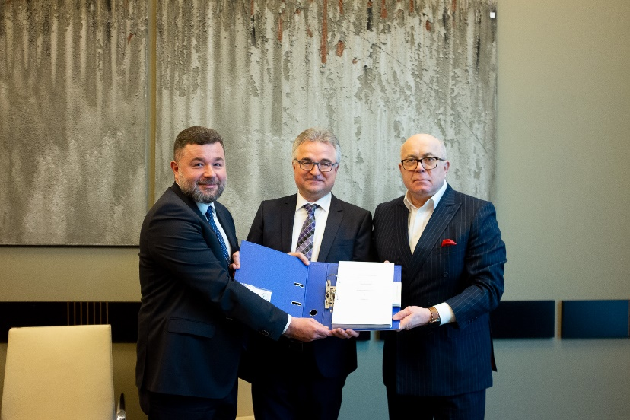
Caption: Signing the contract with Andersia Retail
From left to right: Piotr Kledzik (CEO of PORR S.A.), Dariusz Wietrzyński (Member of the Board of PORR S.A.), Adam Trybusz (CEO of Andersia Retail Sp. z o.o.). ©PORR
In case of questions please contact:
Cornelia Harlacher
Head of Media Relations & Digital Communications
PORR AG
M +43 664 626 5698
comms@porr-group.com
Dominik Heiden
Media Relations Specialist
PORR AG
M +43 664 626 5867
comms@porr-group.com

